
FACULTY

OF

ENGINEERING

AND

TECHNOLOGY

Department

of

Computer

Engineering
01
AI
0506

–

Design

and

Analysis

of

Algorithm

–

Lab

Manual

PRACTICAL-02
AIM: Implementation and Time analysis of linear and binary search algorithm.
1.) LINEAR SEARCH
ALGORITHM:
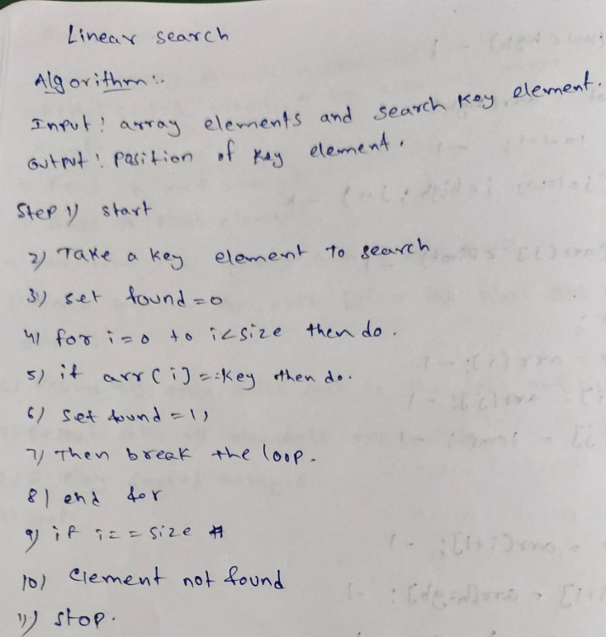
PROGRAM:
#include <iostream>
using namespace std;
int main() {
int arr[20],n,key,i;
cout << "Enter the number of elements: ";
cin >> n;
cout << "Enter the array elements: ";
for (int i = 0; i < n; i++) {
cin >> arr[i];
}
cout << "Enter the element to search: ";
cin >> key;
for (int i = 0; i < n; i++) {
if (arr[i] == key) {
cout << "Element found at index " << i;
return 0;
}
}
cout << "Element not found";
return 1;
}

OUTPUT:
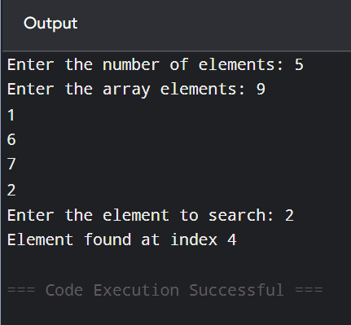
TIME COMPLEXITY:
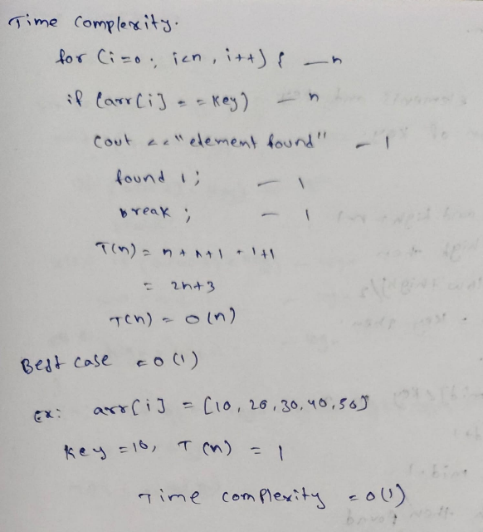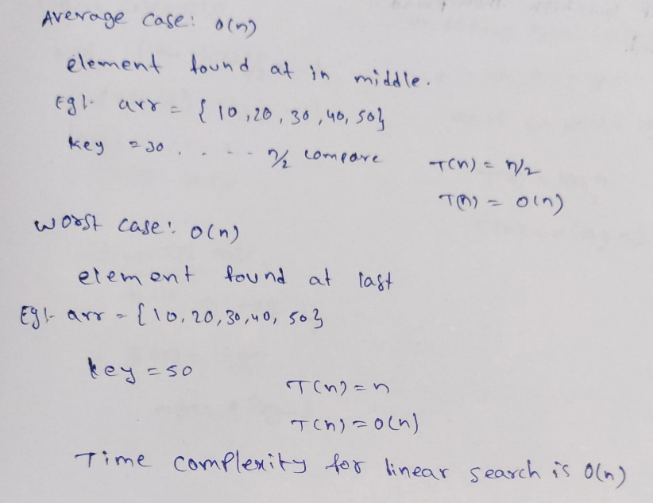

2.) BINARY SEARCH
ALGORITHM:
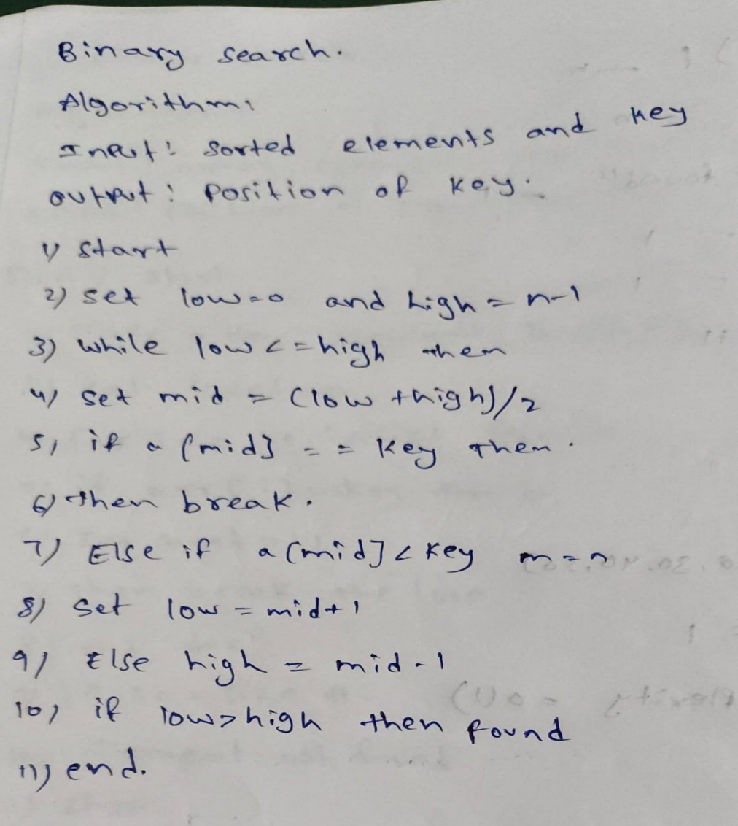
PROGRAM:
#include <iostream>
using namespace std;
int main()
{
int n, key;
int low, high, mid;

cout << "Enter the number of elements: ";
cin >> n;
int a[n];
cout << "Enter the sorted array elements: ";
for (int i = 0; i < n; i++)
{
cin >> a[i];
}
cout << "Enter the key element: ";
cin >> key;
low = 0;
high = n - 1;
while (low <= high)
{
mid = (low + high) / 2;
if (a[mid] == key)
{
cout << "Element found at position " << mid << endl;
break;
}

else if (a[mid] < key)
{
low = mid + 1;
}

else
{
high = mid - 1;
}
}
if (low > high)
{
cout << "Element not found" << endl;
}
return 0;
}
OUTPUT:
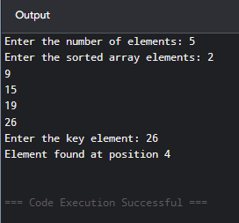

TIME COMPLEXITY:
